

**IE421 FACILITIES DESIGN AND PLANNING**

**PROJECT REPORT**

| **Student Name** | Özkan Perçin |
| --- | --- |
| **Student number** | 200114012062 |
| **Education type** | Second Education |
| **Project Name** | Set Covering Objective Function: Wi-Fi Access Point Planning |
| **Supervisor** | Assoc. Prof. Dr. Süleyman METE |
| **Due date** | 31 December 2024 |

**Table of Contents**

**1.Introduction..........................................................................................................................................3**

**2.Mathematical Model...........................................................................................................................4**

**3.Application...........................................................................................................................................4**

**4.Result....................................................................................................................................................7**

**REFERENCES.......................................................................................................................................9**

**ANNEXES...............................................................................................................................................9**

**1.Introduction:**

With the developing technology, the importance of the internet is increasing day by day. Pamukkale University Kınıklı Campus needs an effective Wi-Fi access network so that students and staff can continue their academic and social activities uninterruptedly. However, existing access points face problems such as insufficient coverage, signal collision and additional hardware costs. In this project, the problem of deploying a minimum number of Wi-Fi access points to cover all buildings and open spaces on campus is addressed.

The aim of the project is to create an efficient and economical Wi-Fi network plan across Kınıklı Campus. Set Covering Objective Function (SCP) method is used in this study. The SCP method is a highly effective method for the design of systems that need to cover large areas and focuses on selecting the minimum number of access points to cover each area within a given coverage distance.

GAMS (General Algebraic Modeling System) software was used to solve this problem.

This paper focuses on defining the problem, describing the mathematical modeling approach, presenting the implementation data and discussing the results.

Keywords: Set Covering Objective Function, GAMS, Minimum Access Point, Kınıklı Campus.

**2)Mathematical Model**

In this project, the Set Covering model is preferred because it focuses on selecting a minimum number of Wi-Fi access points to cover all hotspots within a given coverage distance. This approach is suitable for ensuring both efficiency and economy in the placement of Wi-Fi access points at Kınıklı Campus. The model aims to minimize costs while guaranteeing coverage to meet service demands. This ensures that every area of the campus is covered with the required signal strength, while avoiding unnecessary hardware costs.

**Parameters:**

* i: Nodes that need to be covered.
* j: Potential Wi-Fi access points (department, faculty).
* a(i,j): Distance from node i to potential point j.

**Decision Variable**

xj: binary variable indicating whether the j-th access point is selected or not:

xj=

z :Target variable that minimizes the total number of access points selected.

**Objective Function:**

minz=

**j**

The goal is to select the minimum number of access points to cover all nodes.

**Constraints:**

**j:a(i,j)=<80**

This constraint ensures that each node (i) is covered by at least one access point (j) that covers it (distance ≤80).

**3) Application:**

This study focuses on optimizing the placement of Wi-Fi access points in the Kınıklı Campus of Pamukkale University. In the study, binary variables are used as decision variables and the optimal placement of Wi-Fi access points is determined by considering the coverage of key points (buildings and open spaces) on the campus. This model demonstrates how real-world campus layouts and coverage requirements can be effectively used in network design.

The objective function and constraints created in the mathematical modeling process were implemented using the GAMS programming language. In this implementation process, each constraint was expressed mathematically and imported into GAMS. Furthermore, the objective function, which aims to minimize the number of access points required, was also integrated into the GAMS environment. In this way, a practical program for model-based decision making was developed and made ready for analysis. The transformation of the model into GAMS code demonstrates the practical application and effectiveness of the mathematical modeling process.

The results obtained after the mathematical modeling and GAMS implementation are quite significant. The analysis shows that it is possible to minimize the number of access points required while ensuring full coverage across the campus. Furthermore, this modeling process has clearly demonstrated the influence of factors such as coverage distance and node distribution on the optimal placement of access points. Based on these analyses, important steps have been taken to design an efficient and economical Wi-Fi network considering various constraints and factors. In conclusion, the mathematical modeling and GAMS implementation process proved to be highly efficient and effective for Wi-Fi network optimization.

**3.1) Data Source**

The data used in this project consists of a combination of hypothetical and real-world sourced metrics to address the problem of placement of Wi-Fi access points across Pamukkale University Kınıklı Campus. The distances (a(𝑖,𝑗)) between nodes (buildings and open spaces) and potential Wi-Fi access points were calculated using the Euclidean Distance formula to accurately represent the physical distances on campus. These distances reflect straight line measurements between coordinates obtained from mapping tools such as Google Maps. Potential Wi-Fi access point locations were selected to cover key areas of the campus and provide efficient coverage.

This dataset and methodology is in line with standard practices in network planning and infrastructure design, such as municipal Wi-Fi network projects, geographic information systems (GIS) or communication system studies. This approach provides a realistic and practical framework for designing an efficient Wi-Fi network.

**3.2) Data Sets and Parameter Definitions**

**Departments (𝑖):** A total of 20 departments and open areas are considered across Kınıklı Campus. These nodes represent the demand points where Wi-Fi coverage is required.

**Potential Wi-Fi Access Points (𝑗):** Twenty potential locations for Wi-Fi access points were identified. These locations include central areas of the campus and areas suitable for infrastructure installation.

**Distances (a(𝑖,𝑗)):** A distance matrix represents the Euclidean distance between each department and each potential Wi-Fi access point. These values were calculated using GPS coordinates and reflect the coverage of standard Wi-Fi equipment.

**Coverage Limit:** The maximum coverage distance for an access point is set to 80 meters, balancing technical limitations and coverage requirements.

**3.3. Parameter Definitions**

**x(j):** Binary variable indicating whether a Wi-Fi access point is located at location j.

**a(i, j):** Binary variable representing whether department i is covered by access point j.

**z:** Total number of Wi-Fi access points deployed; minimized in the objective function

**Figure 1:**Google Maps View for Departments

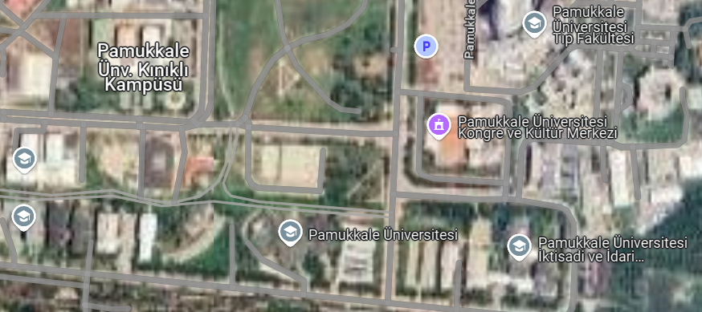

| Point | Departments of Pamukkale University |
| --- | --- |
| 1 | Economics and Administrative Sciences |
| 2 | Faculty of Law |
| 3 | International Trade and Finance |
| 4 | Management and Composition Systems |
| 5 | English Business Administration |
| 6 | Econometrics |
| 7 | Political Science and Public Administration |
| 8 | Dentistry |
| 9 | Architecture and Design |
| 10 | Morphology Cafeteria |
| 11 | Faculty of Medicine |
| 12 | Dean of Faculty of Medicine |
| 13 | Library |
| 14 | School of Foreign Languages |
| 15 | Human and Social Sciences |
| 16 | Faculty of Arts and Sciences |
| 17 | Faculty of Tourism |
| 18 | Civil Engineering |
| 19 | Geological Engineering |
| 20 | Music and Performing Arts |

**Figure 2 :**Gams Code:

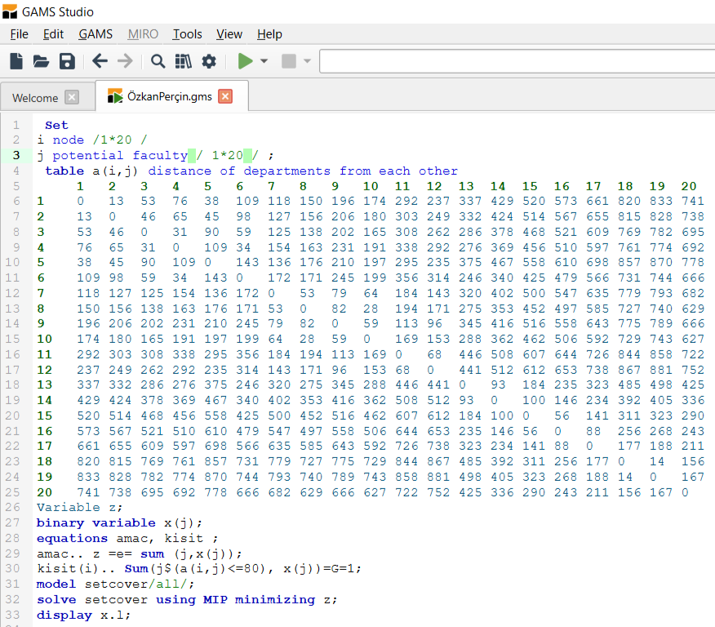

**4) Result**

The model developed for the optimization of Wi-Fi access points across Pamukkale University Kınıklı Campus was successfully implemented. Using the Set Covering Problem (SCP) method and GAMS software, the minimum number of Wi-Fi access points is determined to ensure that all points on the campus are covered within a coverage distance of 80 meters.

According to the model results, Wi-Fi access points should be placed in 10 different locations. These locations are as follows:

* English Business (Point 5)
* Econometrics (Point 6)
* Political Science (Point 7)
* Faculty of Medicine (Point 11)
* Library (Point 13)
* School of Foreign Languages (Point 14)
* Faculty of Humanities and Social Sciences (Point 15)
* Faculty of Tourism (Point 17)
* Faculty of Construction (Point 18)
* Faculty of Music and Performing Arts (Point 20)

**Figure 3:**GAMS Code Analysis Result

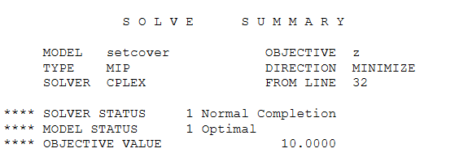

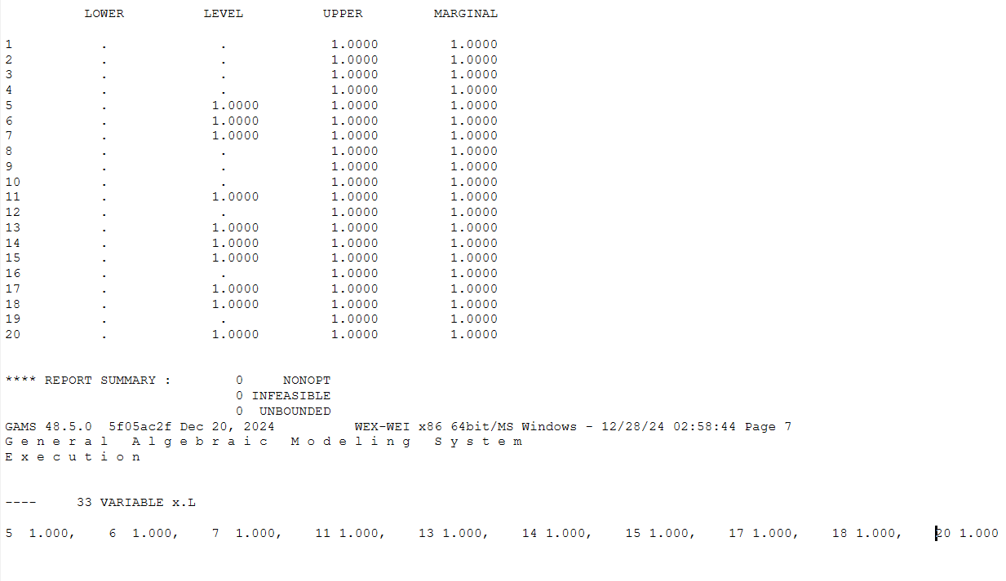

**REFERENCES**

1. Manla, L., Khanji, O., & Özceylan, E. (2023). Location-Allocation Optimization of Wi-Fi Access Points at Gaziantep University Campus. Proceedings of the International Conference on Industrial Engineering and Operations Management, 2125-2135.
2. IE421 Lecture Notes 4-5 (2024). Set Covering and Maximal Coverage Location Problems. Pamukkale University.
3. Google Maps (2024). Pamukkale University Kınıklı Campus Mapping Data. Available at: <https://maps.google.com>
4. GAMS Official Website (2024). General Algebraic Modeling System. Available at: <https://www.gams.com>

**ANNEXES**

**Figure 4 :**Departments Calculated wWth Euclidean Distance

